# **Outfit of the Day**

**Zoe's avatar**

[Zoe](https://substack.com/@zoeffc)

Aug 16, 2024

Share

Hey!

I was interviewing for a job a couple of weeks ago and in our initial small talk, my interviewer complimented my outfit. We ended up talking about how “work clothes” can sometimes act as armor. With that in mind, I wanted to talk about the power of getting dressed for work (or not).

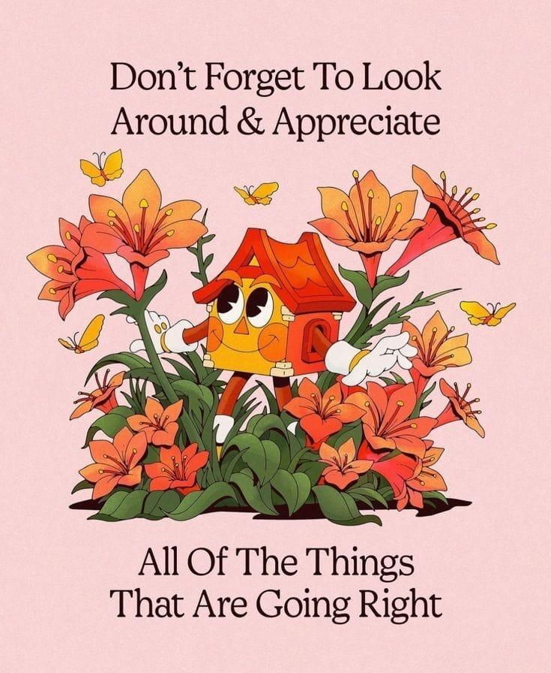

*artist unknown*

First some housekeeping:

📫 If a friend forwarded you this newsletter (then you have some really cool friends), and you may want to consider joining us [*here*](https://femme-futures.beehiiv.com/subscribe) for regular updates.

[Subscribe](https://femme-futures.beehiiv.com/subscribe)

🧲 Got some thoughts you want to share? Join us on [*Discord*](https://discord.gg/592wuyvx?utm_source=femme-futures.beehiiv.com&utm_medium=referral&utm_campaign=outfit-of-the-day) to chat all things newsletter and corporate life.

[Discord](https://discord.gg/N84WxemQ?utm_source=femme-futures.beehiiv.com&utm_medium=referral&utm_campaign=outfit-of-the-day)

I am one of those people who gets dressed with the intention of having my external appearance complement my internal experience. While this makes my mornings long and arduous, I usually leave the house feeling somewhat emotionally settled. This could mean that I am wearing as much black and oversized clothing as I can find because if I am in a grumpy mood, the world must know. Other times, I crave wearing the brightest colors in my closet because I want to bring color into my world or my day. I will wear my overalls if I want to feel like the environmentally conscious and outdoorsy person that I am, and I will wear a flower-patterned dress if fairy energy is in order.

The clothes that you put on your body can be aspirational as well. Sometimes I want to be the kind of person who wears a blazer — rare, but it happens. Right now, I have my eyes on a new pair of boots that I know will make me into the person I am trying to become. [Please read the self-deprecating humor in that… clothes and fashion can emphasize what is already, not change you entirely.]

I work in development, which is code for “my job is to know how to ask for big sums of money from wealthy people and organizations”. At my current organization, this role comes with an expectation of a professional appearance. This means that I officially have a work wardrobe and that I don work clothes most weekdays. This is where armor comes in.

In getting dressed for work, my options for clothes are narrowed by the limited definition of professionalism. Jeans are for Fridays, and graphic tee’s are for weekends. Sure, I can choose to wear my green slacks or my black slacks or my blue slacks — and whether I pair that with a button up, a knit sweater, or a blouse. But as I make those decisions every morning, I still check in with what my emotional needs for the day are. Sometimes, that need is protection. Yesterday was one of those days. I ended up wearing black slacks, a blue turtleneck, and my Doc Marten’s with some gold accents. Doesn’t sound like armor, but it felt like it.

I grew up wearing school uniforms. Maybe that is why I overthink my outfit choices every day — it is still novel for me to make these calls about my appearance. Somedays, I crave my old uniform. I miss the anonymity and the shield that is not telling the world exactly who you are by the things you put on your body. Sometimes I miss not thinking about what I put on my body. I have go-to outfits that serve this purpose too. [Me and Steve Jobs are one and the same.] These are days where I put clothes on and allow them to just be clothes.

I like the daily exercise of checking in with myself and going from there. I think that it pushes me to have a level of self-awareness and confidence as I move through the world. That self-knowledge shows up in the wildest places sometimes.

Today is a work-from-home Friday for me and I already know exactly what I will wear. Work-from-home Fridays were MADE for sweatpants and a comfortable, yet still presentable, top.

Happy Friday!

Zoe

**Femme Futures Cooperative Founding Principles**

💚**Mission**: The mission of Femme Futures is to create a community space for young professionals who identify as over-achievers and activists to generate collective success by providing resources and platforms to thrive in challenging workplace environments.

💙**Vision**: To contribute to a world where driven individuals are equipped with the tools, guidance, and connections to overcome systemic barriers, fully utilize their talents, and enact positive change in their organizations and communities.